Name: ______________________________

Law of Conservation of Energy – Practice Problems

- An "old style" (incandescent) light bulb converts energy as shown in the Sankey diagram below:
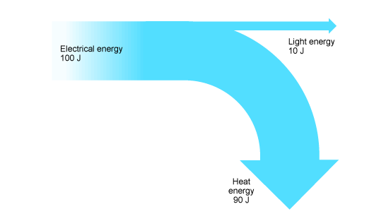
  - For every 100J of energy that the light uses, how much is converted into light energy?
  - For every 100J of energy that the light uses, how much is converted into heat energy?
  - We'd consider the "useful energy" to be what?
  - We'd consider the "wasted energy" to be what?
  - Calculate the efficiency of the light.
  - If you were going to use this light bulb to heat a small area, we'd have to redefine what was "useful energy." What would be the efficiency of the light in this case?

- An "new style" (LED) light bulb converts energy as shown below:
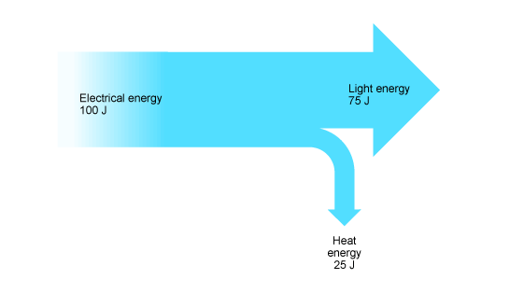
  - For every 100J of energy that the light uses, how much is converted into light energy?
  - For every 100J of energy that the light uses, how much is converted into heat energy?
  - We'd consider the "useful energy" to be what?
  - We'd consider the "wasted energy" to be what?
  - Calculate the efficiency of the light.
  - If you were going to use this light bulb to heat a small area, what would be the efficiency of the light?

- A roller coaster uses 1 000 000 J of energy (Work in) to get to the top of the first hill. During this climb, it gains 400 000 J of potential energy and pauses (velocity = 0) for a fraction of a second at the very top before heading down the other side.
  - What's the kinetic energy at the very top?
  - What would be the "useful energy" during it's climb to the top?
  - How much energy was lost due to friction? (Use Ebefore = Eafter).
  - Calculate the efficiency of the roller coaster during this part of the ride (the climb).

- The same roller coaster goes over the top of the first hill and heads downwards. The roller coaster heads down and levels out as it hits the original level.
  - Since they are back at the original level, what do we know about the potential energy at this point?
  - If we assumed that there is no loss due to friction, what would be the kinetic energy at the bottom? (Use Ebefore = Eafter)
  - The actual kinetic energy at the bottom turned out to be 240 000J, what is the efficiency of the roller coaster during this part of the ride?
  - Where would the wasted energy have gone?

