Fire Extinguishers

Water cools and can be used on many fires.  Cannot be used on electric or petrol fires. |  | 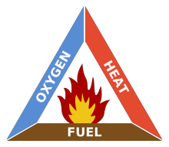
Sand covers the fuel and keeps oxygen away, Can be used on any fire. | 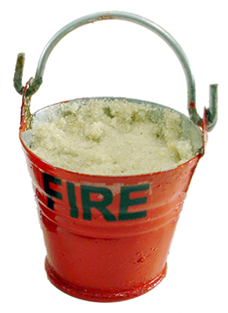
Foam covers the fuel and keeps oxygen away. Can be used on most fires. | 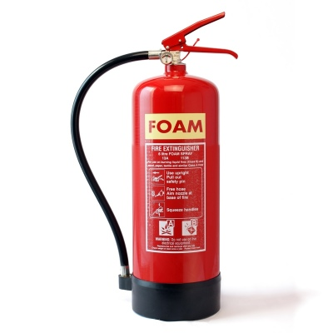
Powder covers the fuel and keeps oxygen away. Can be used on ALL fires. | 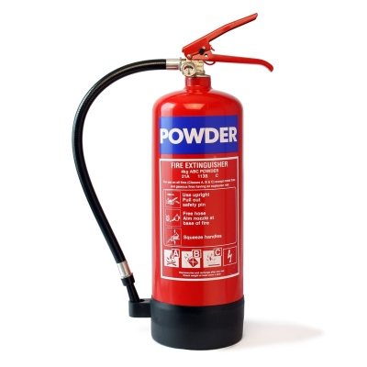
Carbon dioxide replaces the oxygen. Is safe on all fires. | 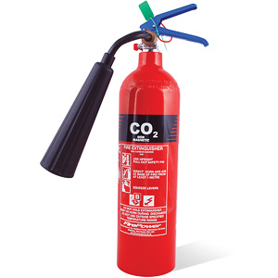
Fire blankets keep oxygen away. | 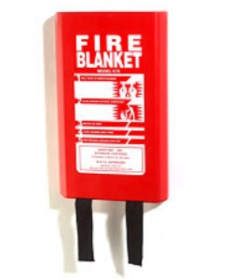
Task 1 – Cross out the part of the fire triangle that is removed by each piece of equipment.

Task 2 – Produce a poster explaining the fire triangle and, using the examples above, showing how some fires can be stopped.

